HOW TO PRAY THE PRECIOUS BLOOD DEVOTION
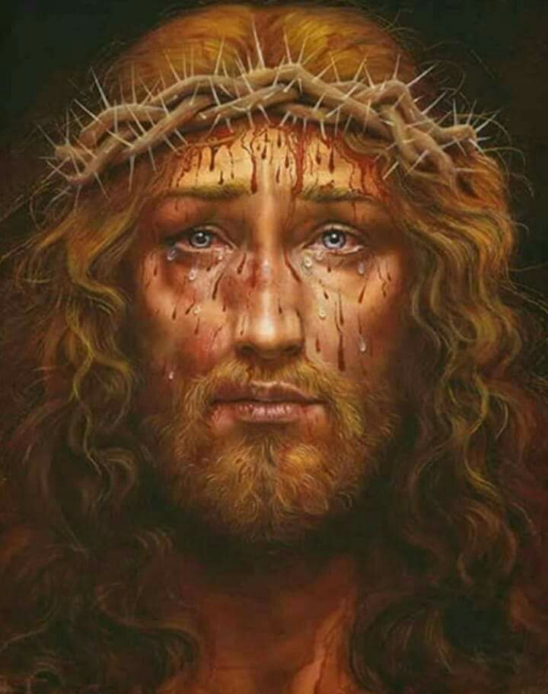

This is the Devotion to the Precious Blood of Our Lord Jesus Christ as given by Our Lord and Our Lady and a multitude of angels and saints to a nearly illiterate Nigerian teenage boy, Barnabas Nwoye, in the village of Olo, Enugu State, Nigeria, from 1995 - 2003. Our Lord told young Barnabas this is the greatest devotion He has ever given the Church and the last one He will give in this age. This is the ark that will protect and bring the Holy Catholic Church, the remnant faithful and all those you love and pray for safely through the bitter trials of the coming chastisement and into the promised Era of Peace.

There are three main parts to this devotion:
- The Daily Devotion - The minimum daily prayers for a devotee are:

- One Mystery of the Rosary (Joyful, Luminous, Sorrowful or Glorious)
- Chaplet of the Precious Blood
- Litany of the Precious Blood
- Consecration to the Precious Blood
- Any other prayers from the Full Daily Devotion that you can add into your day without neglecting your duties to your family or work. (See list at the bottom of this page)
Pray to the Holy Spirit for guidance in finding the proper balance of prayer, work and family commitment for your particular situation in life. Begin to discard frivolous activities and replace them with silence and prayer. The wise advice of a competent spiritual director is a great blessing for anyone who desires to reach a higher state of perfection in this life and is strongly recommended.

2. The Gethsemane Hours - Every Thursday night from 11pm to Friday morning at 3am are the Gethsemane Hours. These are the actual hours Our Lord suffered in the Garden of Gethsemane. It is best to pray these hours in the presence of Our Lord in exposition or before the tabernacle. If you are not blessed with a local church or chapel open at this hour, there are internet sites with live images of Our Eucharistic Lord in exposition you can visit, or, you can set up a sacred place or altar with a crucifix, image of Christ, crown of thorns, candle, etc. It is best to pray in groups of two or more, but not necessary. If only the minimum of one hour is possible for you, Our Lord requests it between midnight and 3am on Friday. Our Lord has given the prayers below for the full four hour observance. For less than this, we recommend you pray one or more complete sets of prayers each week (all the Anguished Appeals or all the Adoration Prayers, etc.) until you have prayed them all, then begin again.

- All four mysteries of the Rosary (Joyful, Luminous, Sorrowful and Glorious)
- Chaplet of the Precious Blood
- Litany of the Precious Blood
- Consecration to the Precious Blood
- Consolation Prayers
- Adoration Prayers
- The Anguished Appeals
- The Mystical Prayers
- Votive Mass of the Precious Blood and exposition of the Blessed Sacrament, where available.

All three periods of prayer are required to be fully observed every year by all those who are consecrated to the Precious Blood and by all those preparing for their consecration. During the month of July, on the days between the periods of prayer mentioned above, you may either return to the Daily Devotion prayers or continue the novena prayers as an additional offering to our Lord.
3. During the Great Month of July, the Gethsemane Hours continue every Thursday night. In the beginning, a devotee may apply some or all of the prayers of the Gethsemane Hours as their Thursday or Friday Daily Devotion or July Novena. For example, you may pray the minimum Daily Devotion with only one Rosary on Thursday day, then continue with the rest of the prayers during your Gethsemane Hours that night, and offer this all as your Thursday Daily Devotion or Thursday July Novena.
You may also pray either the minimum or full Daily Devotion or July Novena on Thursday day, then all the Gethsemane Hour prayers that night, and offer the Gethsemane Hour prayers as your Friday Daily Devotion or Friday July Novena.
The prayers may be prayed in any order with the exception of the Chaplet which must immediately follow the Rosary. You do not have to pray all the prayers at one sitting. You may offer them little by little throughout your day.
As you mature in this life of prayer, and as time permits in your personal schedule, you may eventually be able to pray the Gethsemane Hour prayers in addition to your daily prayers of Thursday and Friday. As Fr. Evaristus Eshiowu once stated, "He who is hungry, eats more."
4. Third Friday Reparation - Our Lord told Barnabas that much of the chastisement could be avoided if enough people would come together in churches and offer this day of prayer in reparation for the sins committed against the Eucharist and His Precious Blood throughout the world.
5. September 14th, Triumph of the Cross - This is a great celebration in this devotion and is offered in all solemnity with candlelight and song. We look forward to the day when the Triumph of the Holy Cross will become the first day of the Glorious Reign of Peace.
Consecration to the Precious Blood - After you have prayed the three main parts of this devotion for five consecutive months and have reflected deeply on making a life-long commitment to the prayers as indicated, then if you feel called, you may present yourself to become consecrated to the Precious Blood of Jesus Christ. Any priest can perform the consecration. The details can be found in our upcoming book The Complete Devotion to the Precious Blood or on our website at www.PreciousBloodInternational.com or by contacting us.
One year after your consecration, you may begin a series of retreats and studies designed to teach you how to practice the virtues to a heroic degree. By studying Our Lord's teachings carefully and applying them to your daily life, you will quickly grow in holiness. On your third anniversary, you may renew your consecration and receive the Rose of Perfect Purity. This can be repeated every three years.
If family duties or poor health prevent you from making this commitment, you can join our spiritual prayer association, The Little Lambs of His Most Precious Blood. You may do this by offering whatever prayers you can with your daily sufferings to Our Crucified Lord through His Mother's Sorrowful Heart at the foot of the Cross, in union with all the Little Lambs of His Most Precious Blood throughout the world. Offer it all for the work of the Association of the Precious Blood in the world; which is the salvation of souls, the sanctification and needs of all priests and the spread of this devotion around the world. We offer a Mass on the Third Friday of each month for the personal intentions of each member as well as remember them fondly in our daily Masses, prayers and adoration.

